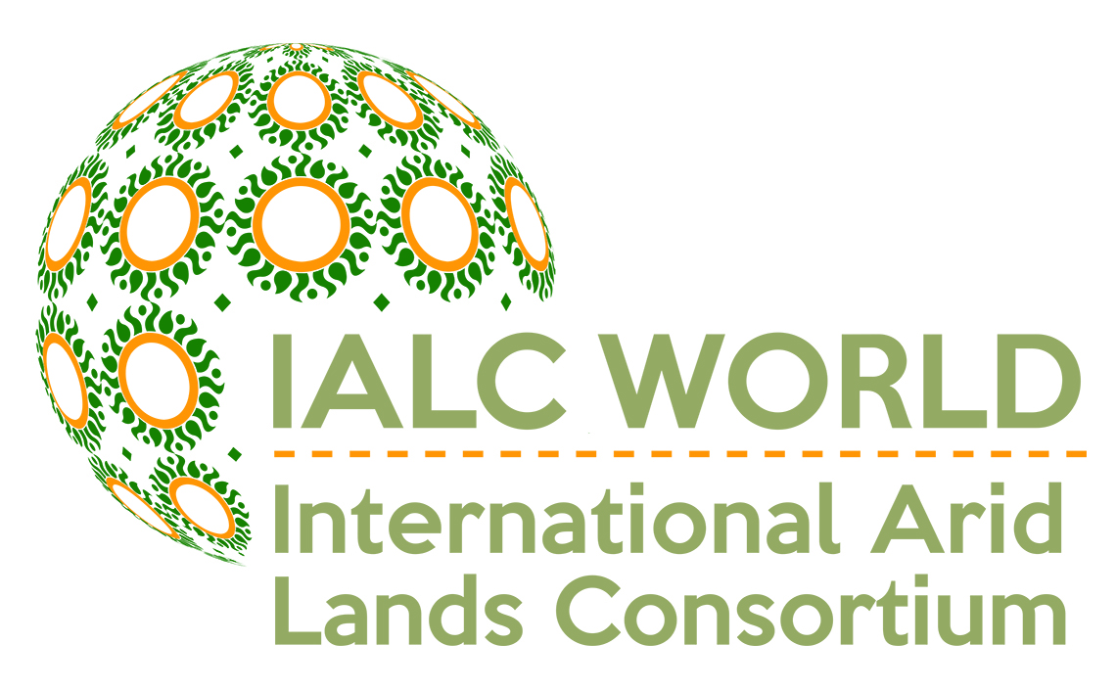
International Arid Lands Consortium:
The Advantage of Expertise, Experience, and Collaboration
http://ialc.world

What is the International Arid Lands Consortium (IALC)?
- IALC is a consortium currently made up of six universities and institutes and research/management organizations in Israel and Jordan.

How does the IALC operate?
- IALC is a registered NGO and is also a 501 (c) (3) non-profit organization.

What is the focus of IALC Activities?
- IALC has worked successfully for more than 25 years on international research, demonstration, and development projects as well as faculty and student educational programs, exchanges, workshops, conferences, and distance learning opportunities. Interests are focused on the people living in semi-arid and arid regions of.

What are the IALC’s capabilities?
- The members of the IALC are all highly experienced institutions that have worked together across national and cultural borders. As such, the IALC has capabilities that are critical for advancing human development and promoting peace in arid and semi arid areas of the world:
  - Food security, including agricultural and natural resource research and extension system design, development and assessment
  - Business management and marketing, especially in agricultural products
  - Human resource development including youth development and degree granting graduate and undergraduate programs, special educational courses, and higher educational institutional development related to natural resources and the environment
  - Natural resource management including biodiversity, watershed management, soil resource conservation, eco-tourism and natural resource inventory, and information technology applications for natural resource management
  - Water resource development, conservation and management including water quality for primarily human use, water harvesting and reuse, and water for agriculture irrigation
- IALC has a large pool of tested expertise from among thousands of faculty, scientists and extension personnel.
- IALC has demonstrated administrative capability to effectively support international initiatives with a variety of donor institutions.
- IALC has successfully implemented and managed competitive grants programs.
- IALC provides a simple and accountable management and authority line for addressing problems and issues that arise in program implementation.
- IALC is inherently international with three non-US institutional members and is sensitive to the need for collaboration to bring the best that is available in international programs.

What is the IALC’s Record of Accomplishment?

The IALC managed the project: “Sustainable Development of Drylands in Asia and the Middle East” through a Cooperative Agreement with the U.S. Agency for International Development. Included on the project were the University of Arizona; University of Illinois at Urbana-Champaign; and New Mexico State University along with the Badia Research and Development Centre, Jordan. Advisory institutions included the Desert Research Institute, Nevada; Jewish National Fund/KKL, Israel; South Dakota State University; and Texas A&M – Kingsville. This seven-year Cooperative Agreement implemented three interdependent objectives: (1) improve wise use and re-use of water, treated wastewater and soil resources at the farm, community and regional levels; (2) support human and institutional capacity development in arid lands agricultural development and conservation by partnering with educational and other institutions of host country nations, (3) apply appropriate technology, especially information technology, to support sustainable arid lands development.

Project Components

1) Afghanistan/Pakistan Component: Human Capacity Development for the Agriculture Sector: Led by the University of Illinois at Urbana-Champaign, UIUC. This Component conducted short-term high impact training through technical courses ranging from soils management, orchard management, irrigation practices, extension methodology, post-harvest management and food preservation, and animal nutrition as well as others.

UIUC Team and Cooperators Accomplishments:
- 441 persons trained including 46 women (train-the-trainers methods)
- 23 technical courses given (in appropriate local languages)
- 24 scientists trained from the Ministry of Agriculture, Irrigation, & Livestock
- 20 university teachers and Ministry officials educated to MS level
- 10,000 textbooks distributed
- University level capacity building accomplished
- Attracted more than $1.5 million in additional funding from RAMP-Chemonics-USAID project, HED funding for Balkh University, and FAO funding for additional training

2) Jordan Water and Environment Component: Treated Wastewater and Bio-solids Reuse: Led by the University of Arizona (UofA) and Badia Research and Development Centre (BRDC). This Component focused on providing USAID-Jordan and the government of Jordan key expertise in the safe re-use of treated wastewater and bio-solids principally destined for application to farmlands through intensive training (laboratory, lecture and field), scientific study tours, applied on-farm research in Wadi Musa, just outside of Petra.

UofA/BRDC Team and Partners Accomplishments:
- 7 Jordanian institutions received capacity building
- 7 Workshops, held in Jordan , 1 Regional in Egypt (250+ persons)
- 4 Advanced study tours to US completed (14 scientists)
- 4 Monitoring studies completed (2 wastewater, 2 efficient use of water)
- 4 Applied research and demonstrations completed (biosolids characterization,
bio-solids technology develop., bio-solids to farmland (2))
- Graduate-level real-time Internet based distance learning course (Irrigation management of reclaimed water with high salinity)
- 1 Bio-solids national regulatory standard revised (project supplied technical input and funded govt/research ad hoc committee that championed the revision)

3) Jordan Agri-Business and Marketing Component: Led by New Mexico State University (NMSU) and the Badia Research and Development Centre (BRDC), Jordan. The project, “Business and Socioeconomic Assessment of Water and Products for Community-Based Projects in the Badia Region,” provided technical assistance to Jordanian government-sponsored, but privately run cooperatives on economic feasibility analysis of various cooperative business, business planning, management, and marketing of produce.

NMSU/BRDC Team and Partners Accomplishments:
- 2 Workshops in Jordan in Project Management
- 2 Study Tour to US in Project Planning and Management
- 2 Cooperatives Business Plans (completed)
- Case study presented at ANE supported Cairo Linking Farmers to Markets Consultation
- 1 Major water and economics study for key Jordanian aquifers (completed)

4) Agricultural Electronic Libraries (AEL) Component: Led by the University of Arizona (with Kabul University (KU) and Nangarhar University (NU), Afghanistan). Development of an agriculture electronic library for the College of Agriculture at Kabul University was begun in the spring of 2004 and then expanded to Nangarhar University in 2006/2007.

UofA Team and Partners Accomplishments:
- 1 refurbished library and training room at Kabul University with
- delivered and functioning computers, workstations, printers, copier & furniture
- electronic databases, including TEEAL, plus other software
- 60 faculty and students trained (train-the-trainer)
- 4 staff members hired and trained (2 + 2 replacements)
- 50 person per day utilization rate
- UofA research scientist has now completed the work at Nangahar University which mirrors what was done at Kabul University.
- Efforts are underway for 2008 to replicate this work in Yemen at two universities.

5) Agri-Business Consultations Activity: Linking Farmers to Markets: Led by the University of Illinois at Urbana-Champaign. UIUC, in cooperation with USAID-ANE and a number of participating USAID-Missions, provided expertise for three international consultations/ workshops. Mission personnel, academic institutions and the private sector were trained to look at how farmers and markets interact and how farmers can better access these markets -- local, regional and international.

UIUC Team and Partners Accomplishments:
With ANE and Mission (Egypt) Support, UIUC team:
- Completed successful Chicago Linking Farmers to Markets Consultation with regional USAID, multiple Mission and Washington participation
- Completed successful Cairo Linking Farmers to Markets Consultation with regional USAID, multiple Missions and Washington
- Completed 3rd Consultation in New Delhi in 2007.
- Attracted additional support for implementation of recommendations through the Global Development Alliance and private funding.

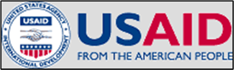

Other IALC Accomplishments:

- The IALC was authorized by Congress in 1990 and reauthorized in the 1996 Farm Bill.

- Since 1993, the IALC has received funding from the: USDA Forest Service ($6,512,383), USDA CSREES ($5,306,335), and USAID ($6,214,380).

- The IALC has received additional support from San Diego State University Foundation; Egyptian Ministry of Agriculture and Land Reclamation; Archer Daniels Midland Corporation; and Arizona Public Service. Also, IALC member institutions have provided financial and in-kind support for the IALC and its operation.

- Using a scientific peer-review process, the IALC has provided $11.8 million to fund 91 research projects; 30 demonstration projects, and 11 special initiatives (e.g., conferences, symposia, workshops, technical training, and other projects) in eight countries to date.
  - Selected project topics: conservation (30); water quality (28); irrigation (25); GIS & remote sensing (24); ecology (23); agriculture (20); wildlife management (18); rangeland management (15); wastewater (14); biodiversity (13).

- Eighty percent of the research projects have involved international collaboration, while many of the remaining projects involved collaboration at an IALC member institution. Thirty-three percent of the demonstration projects had international collaboration and all demonstration projects had interdisciplinary cooperation.

- The IALC has had memoranda of understanding and cooperative agreements with other U.S. and foreign institutions including: the Hashemite Fund for Development of Jordan Badia (HRDB), Center for Middle East Peace and Economic Cooperation Center, U.S. Department of Energy and Middle East Water and Energy Resource Institute (MEWERI), San Diego State University Foundation, Ben-Gurion University of the Negev, and Jacob Blaustein Institute of Desert Research.

- The IALC sponsored 19 undergraduate and graduate students through the IALC Peace Fellowship program. Fourteen students traveled from U.S. IALC Member Institutions to conduct research in Israel and/or Jordan, while five students traveled from Israel or Jordan to conduct research at one of the U.S. Member Institutions.
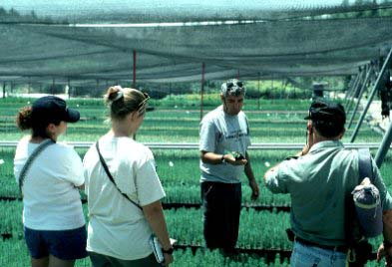
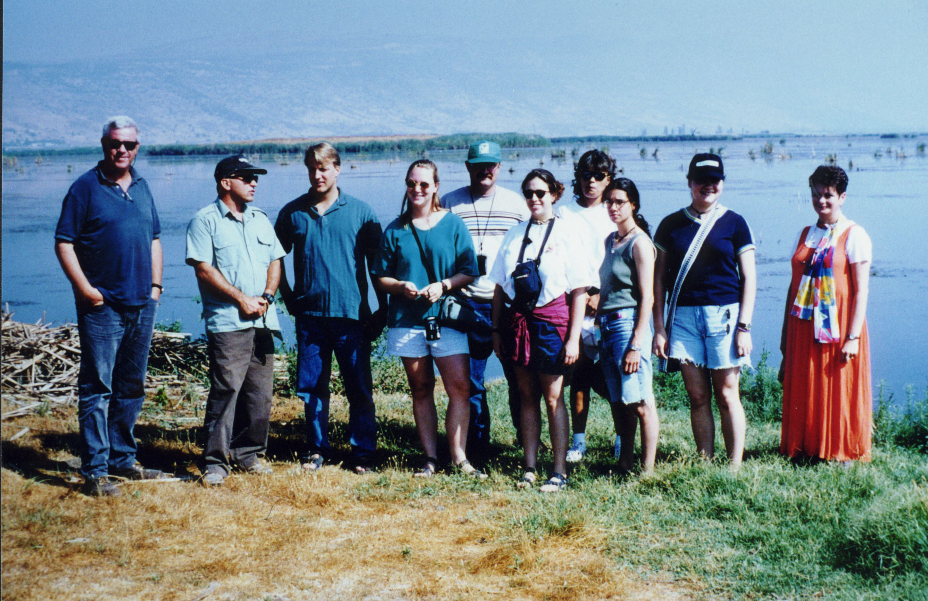
IALC
Peace Fellows

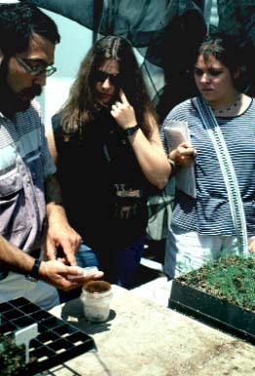

- Participation in selected IALC conferences: September 2017 International Conference: Cutting-Edge Solutions to Wicked Water Problems in Israel; November 2012 in Israel (special session and reception at the 4th International Conference, Drylands, Deserts, and Desertification); April 2007 in Israel (75 attendees from 10 countries); October 2002 in Tucson (80 attendees from 8 countries); May 1997 in Israel (100 attendees from 10 countries); and May 1995 in Israel (40 attendees from 8 countries). Workshop participation: November 1999, Reno NV (80 attendees from 4 countries); June 1999, Jordan (50 attendees from 10 countries); June 1994, Israel (200 attendees from 30 countries); and December 1995, Israel (75 attendees from 15 countries). Technical Training: Jordan and Israel to 30 attendees from 3 countries.

- Selected IALC projects have produced: 225 refereed journal articles; 63 books, doctoral dissertations, and master’s theses; 135 presentations at conferences, symposia, and workshops; 12 newly-created Websites; and 26 other outcomes such as awards, technical reports, and training manuals. Members of the IALC Research and Demonstration Advisory Committee have also produced 2 journal articles, 1 technical report, and made 5 formal presentations at conferences and workshops related to IALC activities.

- The IALC website is available at: https://ialc.world/

- Selected Special Initiatives: conferences and workshops:
  - 4th International Conference: Drylands, Deserts, and Desertification (Israel) (2012)
  - Afforestation and Sustainable Forests as a Means to Combat Desertification (2007)
  - Biodiversity and Management of the Madrean Archipelago II (2004)
  - Assessing Capabilities of Soil and Water Resources in Drylands: The Role of Information Retrieval and Dissemination Technologies (2002)
  - IALC Land Management Workshop: A 10th Anniversary Celebration of USFS, CSREES, Israel, and IALC Partnerships (1999)
  - Biodiversity in Drylands: Research, Management and Demonstration Needs (1999)
  - Technical Training Course on Mitigating Risks to Conservation and Sustainable Use of Water and Other Natural Resources (1999, Jordan and Israel)
  - An International Management Training Workshop on Arid & Semiarid Ecological Systems (Nov - Dec 1995, Israel)
  - International Symposium on Sustainable Water Management in Arid and Semiarid Regions (15 - 19 May 1995, Israel)
  - International Workshop on Arid Lands Management: Towards Ecological Sustainability (19 - 24 June 1994, Israel)

University of Arizona, Desert Research Institute-Nevada, New Mexico State University, South Dakota State University, Texas A&M-Kingsville, Robert B. Daugherty Water for Food Global Institute at the University of Nebraska
Jewish National Fund, Higher Council for Science & Technology-Jordan

